For the smoke system, should I use billboard sprites instead of 3D meshes. Since each shape is just a blob, this might be a good opportunity to try raymarching.
Then again, the current system looks fine, the only real issue is getting the particles to spread properly. I made a system that was performant, but didn’t actually update the particle positions.

I had another look at the code. I realised the smoke clouds run in FixedUpdate() but the density controller only runs in Update().

I changed the density controller to run in FixedUpdate(), and it actually does things but causes a lot of lag.
I need to check the execution order of the particle density controller, relative to the smoke clouds themselves, and when the particle system itself updates. It’s possible that the particle changes are taking data from last frame, and being immediately overridden by what’s happening the current frame somehow.
I also need to just check how much offset value is being applied, I might need to greatly lower it.

I also noticed that the ‘iterate through particles’ function iterates through the entire array, rather than the actual number of active particles. I’ve fixed that. I’ve also noticed it’s constantly generating new SmokeParticle structs, I’ll probably need to change it to more of an ECS based system that uses functions and properties to get those values.
Alright, I think I do still need the SmokeParticle struct for the ParticleGridSpace class, but I should still be able to change the code to use the origin cloud and index instead.
Nope, I was able to completely eliminate the need for the SmokeParticle struct, and now it’s way more performant! Hooray!
I’ve also noticed that when the simulation is actually running, all the particles seem to go towards world zero. That’s where the magenta debug lines go (that I set up to go from the cloud’s origin point to each particle’s position).

One thing I noticed is that the wonkiness occurs as a result of updating the particles, even if the position isn’t changed. I did two tests – one where I disabled the code changing the particle systems but still ran the apply code (glitched out), and one where the apply code was disabled entirely (which resulted in normal old particle operation). So that lends creedence to the idea that maybe the execution order has something to do with it. It might also have something to do with the particles running on regular time, and the density controller now running on the fixed timescale.
So I’ll need to really look into the different timescales. I might need to either change the smoke cloud and density controller to use the regular Update() loop, or change the particle systems to be manually simulated using the fixed update loop. I’ll need to try both solutions, and decide if I want superior looks or superior simulation.
I also need to figure out the execution order of each class. I don’t think it’s possible (or at least viable) to change the order for the particle system, but I’m pretty sure I need it to simulate first so the offsets can be applied, and then the colliders positioned.

I should also double check and ensure the exact right particles are being obtained. I’ll use GetParticles right at the start of the density controller update loop.

Nothing seemed to be wrong, so I tried increasing the minimum acceptable distance. And it works! I upped it to 5 to see an appreciable difference, but that was too much, so I dialed it down to 2. The smoke expands far better than before, and with far more reasonable performance.

There’s still cleanup to do, though.
I need to ensure the density controller is automatically created, as it needs to be a singleton and I don’t want to have to manually place it in each level.
I’m not sure if the minimum distance should be a fixed value, or instead a multiplier based on the particle’s current size. I might need to make the resolver distance a multiplier as well. Ideally I’ll want to remove all variables from the density controller, so I can instantiate a new one at runtime instead of worrying about how to store a prefab.

I’m also not sure if the ‘particleArray’ and ‘particleOffsetResolvers’ arrays should be in the smoke cloud, or just in the density controller.
Nevermind, I keep forgetting I can’t access individual particles, the entire array needs to be accessed at once. So the particle array does need to be written for SmokeCloud.

TO DO:
- Figure out if minimum distance should be fixed or a multiplier
- Figure out if resolver magnitude should be fixed or a multiplier
- Figure out how to save density controller prefab
- Have code in SmokeCloud’s Awake() function that automatically spawns a density controller singleton

I think I can’t have the minimum distance be a multiplier or change based on the particle, because the minimum size is how the grid size is calculated for bunching up particles. There aren’t different grids based on different particles, there’s only one for the entire environment.

As for the resolver magnitude, I’m not sure. I think if the concern is to have it be realistic and intuitive, I’d think that bigger particles would exert more force on the particles around them, to force them out of their space faster. I might need to also use some kind of inverse calculation to have the offset speed be greater based on how close they are together, so if they’re more tightly packed they’ll push away faster.
And how will the resolver magnitude factor into this? Should it be multiplied onto each value before it’s added, or after? Same with delta time.
And if I want the particles to not accidentally phase into walls, maybe rather than directly adding on the value multiplied by delta time, maybe I should add it onto the velocity instead. Plus if I do that, I won’t need a separate loop for applying the values versus calculating them. But then again that might make things more confusing, so keeping it separate might be better.
Actually, I realised that if I add the velocity, it’ll continually stack up over each frame, causing some unstable behaviour. Since I haven’t really noticed any issues with phasing through walls yet, I’ll continue just tweaking the position instead.
TO DO:
- Figure out if I should bother with that more realistic resolver calculation
- Figure out how to save density controller prefab
- Have code in SmokeCloud’s Awake() function that automatically spawns a density controller singleton

01/12/2025

Is the garbage collection being caused by the ParticleGridSpace class?

I enabled deep profiling, and it turns out a lot of it’s being caused by MiscFunctions.IterateThroughGrid().
The only place in that class where it runs is when it’s checking the adjacent grid spaces. At that place, it creates a new Vector3 each time. I bet that’s causing the garbage.
I changed that but it’s still being the big performance bottleneck.
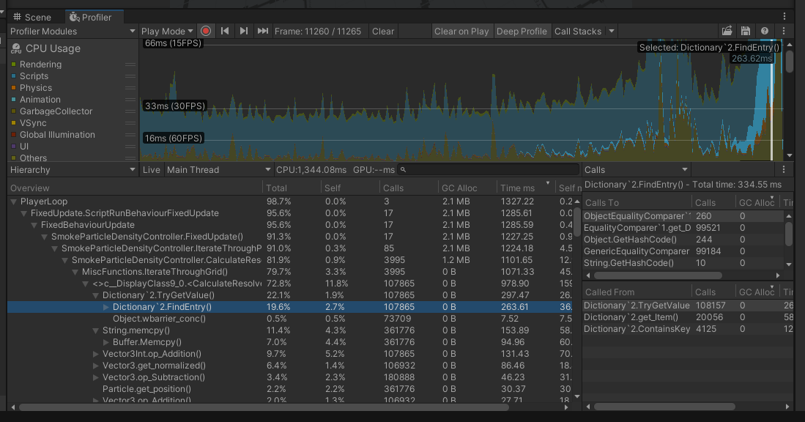
Here we can see that the biggest source of the performance issues – reading the dictionary when checking the grid values. Even though the returned value is a class so no data is being copied, just referenced, the actual process of checking is enough to cause huge slowdowns.

23/12/2025
Hang on, why does my code need 27 checks?
That’s a 3x3 cube. I set it up to be that, but I’m pretty sure I only need a 2x2.
If a particle is close to one edge, if the spaces are big enough I should only need to check the adjacent edge on one side.
After resizing the grid space size to be the same as the check diameter (radius * 2), I just need code to check the non-rounded grid position against the rounded one, and determine what direction to check the adjacent spaces. I think for each axis I can just do ‘non-rounded position – rounded position’ then normalise that.
Actually, getting the sign might be better for this.

24/12/2025
I successfully implemented that system to reduce the number of checks, and it seems to work! The dictionary checking is no longer the main bottleneck. Now it’s the actual process of checking particles in each grid space. Which I’m not really sure how I can reduce further.

I did some more tests with the minimum acceptable distance and the resolver vector magnitude.
I increased the resolver vector to 50X (5 from 0.1), and even with how much they were being shifted the particles in the centre were still quite dense. I think I’ve greatly underestimated how many particles are being spawned at a time.
I need to try reducing the number of active particles.
Alright, this seems to work quite well! I realised each smoke grenade was producing 60 clouds per second, but it still looked great after dropping to only 10 per second.
I reduced the resolver vector magnitude to 1 (higher than the initial 0.1, but lower than the 5 value I was using for testing). I chucked two smoke grenades into the same space for testing, and the system was much smoother.
There are still some downsides though. When adjusting, the particles jitter around in a very erratic manner, and a lot of particles are also phasing through walls. I need to modify how the resolver vectors are applied, to ensure movement is halted if they collide with something.

27/12/2025
To fix the particles, what if I set the velocity instead of the position?
How would I go about having a consistent speed?
What if I used Vector3.MoveTowards() to have the velocity slowly shift?
It seems to work decently well, but needs more testing so I can ensure I’m satisfied. I also need to test with other smoke sources.
It seems to work fine with the handheld fire extinguisher (I still have to test the steam valves, shootable fire extinguishers and smokestacks).
I noticed the grid spaces (or at least the visual representations of them) seem to be off. The sizes seem to be correct but the positions appear to be all messed up.
Alright it seemed to be because of a bug in WorldToGridPosition(), where the distance wasn’t being multiplied correctly. I forgot to put a bracket around ‘minimum acceptable distance * 2’, so the position was only being divided by the radius rather than the diameter, and then multiplied by 2.
I tested in the power plant level. Some severe lagging does seem to be occurring, but I’m not exactly sure what’s causing it. I was worried the stationary smoke plumes would be producing a stupid number of particles, but those have had their rate greatly reduced just like with the smoke grenades.
I did realise however, that the rates aren’t connected. The current stationary smoke plumes just already had a value of 10, and it’s too much.
I’ll try reducing it anyway, from 10 to 5.

